Introduction to BACON

Table of content

1. Objective 3
2. Steps of a session 4
2.1. The pre-processing 4
2.1.1. Ways to introduce data 4
2.1.2. Operations and steps to define a problem 4
2.2. Computation 5
2.2.1. Methods 5
2.2.2. Operations 5
2.3. The post-processing 5
2.3.1. Methods 5
2.3.2. Operations 5
3. Guided exercise 5
4. BACON DATA FILE Management 6
5. Samcef procedure 8
5.1. Sub-menus description. 9
5.2. Choice of execution mode 10
5.3. Chaining modules 10
5.4. Modification of memory space zone 11
5.5. Choice of the language 12
6. Main Screen description (MENU mode) 13

Objective

BACON
CAD
CAD
Entities
BACON
Meshers
FEA
Entities
SAMCEF
Solvers
FEA
Results
External
CAD
External
MESHERS
IGES
Translator
Specific Interfaces

Steps of a session

- Pre-processing
- Computation
- Post-processing

The pre-processing

Ways to introduce data

- Menu
- Keyboard
- Bank file
- Retrieving a CAD file

Operations and steps to define a problem

- Geometry
- Meshing
- Hypothesis
- Choice of finite element :
Shells, membranes, beams, volumes, rods, axisymmetrics

- Properties
- Materials: Elasticity Module, Poisson’s ratio, ...
- Thickness

- Loading
- Nodal Forces, pressure, weight, acceleration, ...

- Boundary conditions
- Fixed displacements, symmetry conditions, links, …

- Exporting computation file
- Creating a file containing data for computation (nodes, elements, properties, ...)

Computation

Methods

- Using the procedure or within BACON
- Interactive or batch processing.

Operations

- Solving the problem
- Computation of displacements, stresses, strains, temperatures, eigenvalues
- Writing results files

The post-processing

Methods

- Menu
- Keyboard
- Bank file

Operations

- Validation of results

- First validation : Reading the results file (name_nn.res).
- Looking for warning and error messages
- Inspection of matrix diagonal
- Null pivots
- Reactions

- Second validation : graphical analysis
- Isovalues, curves
- Displacements, stresses, deformed shape

Guided exercise

Exercise 3 in exercices manual Holed plate (samcef procedure, menu mode, session steps, …

BACON DATA FILE Management

samrc.ini
Procedure

*.dat
Interactive or menus
bacon.ini

BACON

*.spy
*.sdb & *.sam

SOLVER& FAC

*_yy.des & *_yy.fac

BACON

T = free format file, B = binary

Name | Format | Comments | Generated by ...
samrc.ini | T | User’s customization. | SAMCEF Procedure
bacon.ini | T | User’s initialisation of BACON session (abbreviations) | User
x.dat | T | Command file for BACON | User
x.spy | T | Spy file of the commands used during the session. | BACON
x.sam | B | Data for computation. | BACON
x_yy.des | T | Description of the results | FAC
x_yy.fac | B | Result file | FAC
x.sdb | B | Database | BACON
x_yy.log | T | Resume of the batch operations | BACON

The file samrc.ini

Located at $SAM_HOME location.
Contains some environments variables (memory, language…).

The file bacon.ini

Automatically executed by BACON if located at $SAM_HOME location.
User defined file for customized parameters.

The file bank : <name>.dat

Created by user :
- through text editor,
- through saving command (.sauve bank).

It contains the modeling, post-processing commands or any other command.
User can execute this file for creating data or post-processing.

The spy file : <name>.spy

Created during any BACON session if MODE MOUCHARD is activated.
It duplicates all commands used during the session.
It can be reexecuted in case of unexpected end of session.

The data base file : <name>.sdb

Created by saving command (.sauv db or .fin 1).
It contains informations as: geometry, meshing , loadings, ...
Used by computation modules.

The computation file: <name>.sam

Created at end of pre-processing.
It contains data for computation.

Exercise : number 6 (use of bacon.ini).

Samcef procedure

All SAMCEF modules are executed using samcef command which starts a script. The file names assignation is performed in the samcef.proc file.
samcef is a script used to manage interactive user - samcef dialog and executes modules in order to respect user’s choices : batch, background, .

When samcef command is entered, the following dialog box is displayed :

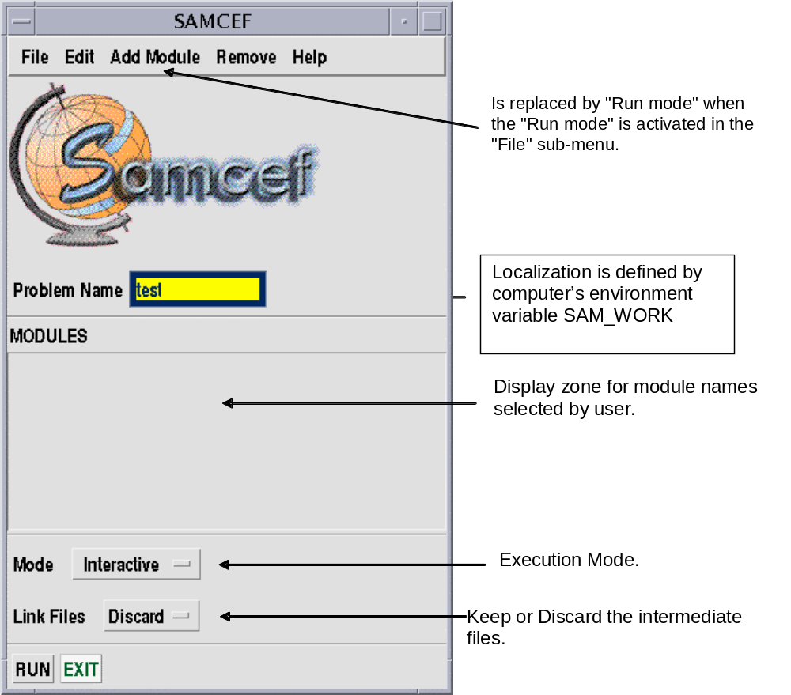

Sub-menus description.

FILE
Run  Creates Run Files  Chain mode  Run mode  Environment  Colors  Fonts  Exit | Run the selected modules  Command file (.csh for UNIX-.bat on PC  User defined Chain (ex: bacon,asef) started by RUN  If Active, it immmediatly executes the selected module.  List of values of environment Variables.  Modification of menu colors  Modification of menu fonts  Exit the program.

EDIT
Session variables  Module Variables  User Defaults | It lists or modifies env. Variables ( language, memory,..) for the current session or for a specific module.

ADD MODULE or EXECUTION
User  Asef  Bacon  … | If selected, the module name to be executed is viewed in the display area.

DELETE
Remove  All | Delete a selected module  Delete all selected modules

HELP
SAMCEF doc  Doc on Topic | Display HTML documentation  Display help for selected command (.NOE) or analysis module (REPDYN,..)

Choice of execution mode

MODE
Detached  Interactive  Batch  Background  Delayed | The module is executed in an other window than the one in which samcef run command has been entered

If Batch is selected :

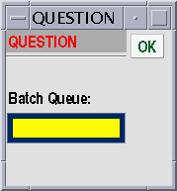

If Delayed is selected :

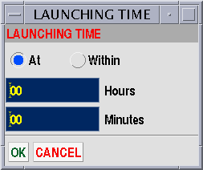

Chaining modules

Example : BACON session followed by an ASEF linear static computation :

samcef ba,as <name> n 1
Exercise :

- rename the .sam and .sdb file and re-run the analysis.

Modification of memory space zone

Selecting the Session Variables :

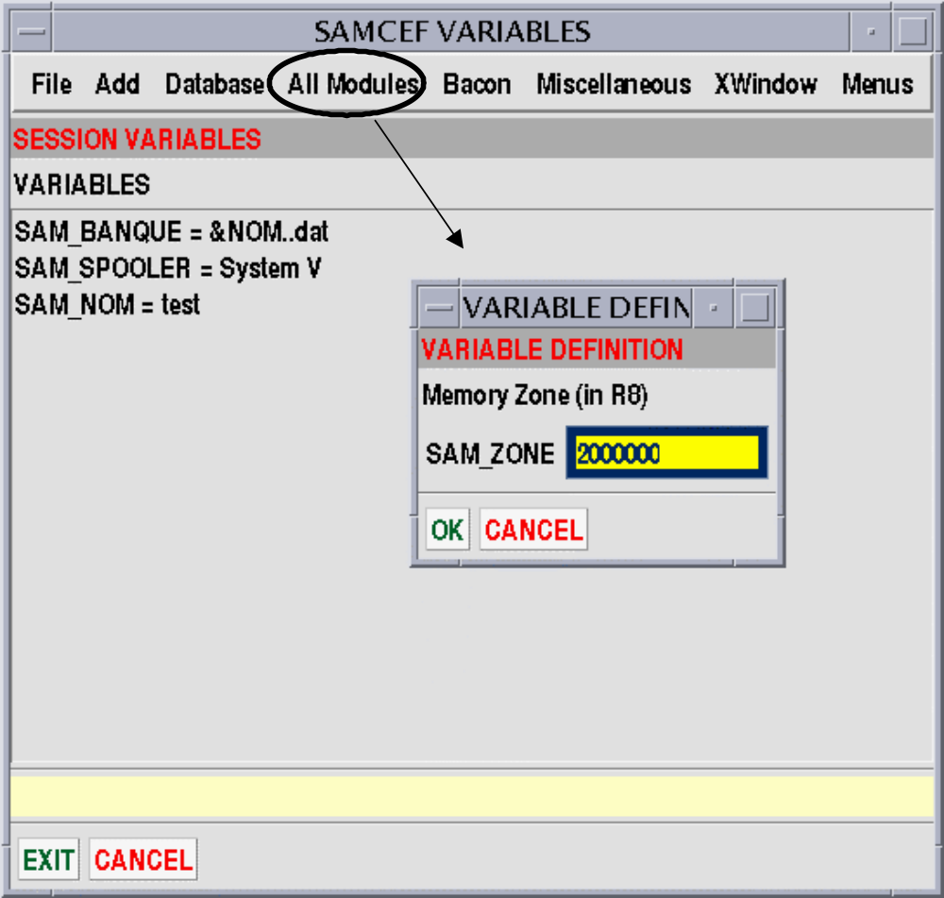

Using editor file (UNIX command) :

Vi samrc.ini
SAM_ZONE <valeur>

Example :

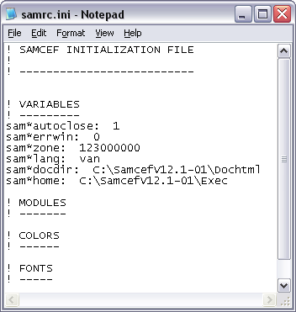

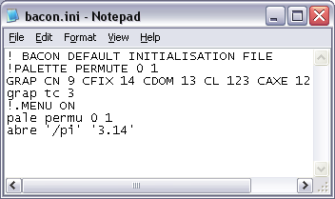

Choice of the language

One can use dialog boxes , or write in .cshrc file :

setenv SAM_LANG van for the english version
setenv SAM_LANG vfr for the french version
Exercise :

- Set a new value for memory space zone ;
- Set a new choice for the language

Main Screen description (MENU mode)

A : Screen display
B : Main menu bar
C : menu configuration
D : Keyboard commands access zone
E : Display zone for program messages and instructions
F : Permanent commands zone (point of view, scales, display options, …)
D : Keyboard commands access zone
G : Sub menus zones

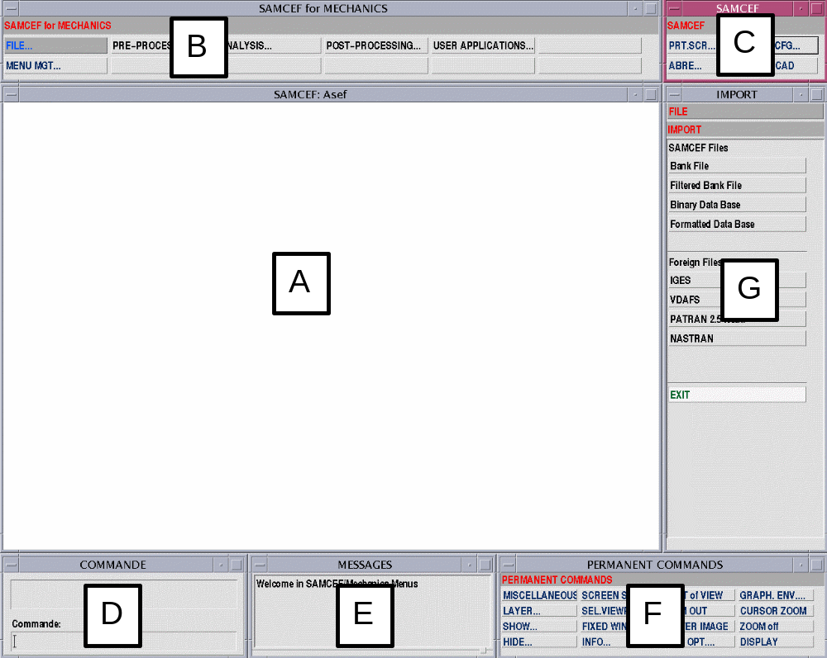

FILE
Open  New  Save  Save as  Import  Export  Export→Computation  Quit  Cancel | Open a file .sdb  Create a new .sdb  Save the current db  Save the db with a new name  Import files  Export files  Create the computation file  Exit the session  Exit the FILE menu | .DOC DB ""  .SAUV DB  .SAUV DB " "  INPUT or .INT  .SAU BAN or.EXP  .FIN 1  .STOP
PRE-PROCESSING
FILE  2D Geometry  3D Geometry  STRUCTURE  JOINTS  GROUPS  FUNCTIONS  Struc PROPERTIES.  Joints Properties  Loadings and BCs  Lin. Exec. Params  Display CONTROL  UNITS  TITLE | Back to FILE menu  Creation of Geometry 2D entities  Creation of Geometry 3D entities  Meshing , Hypothesis, …  Special elements for Motion tool  Creation of groups  Creation of functions  Materials, sections, ...  Motion elements properties  Loadings, Boundary Conditions,  Asef parameters | .POIN, ...  .3POI, ...  .HYP,  .MCE, …  .SEL  .FCT  .MAT, .PHP, .AEL  .MCE, .MCC  .CLM, .JER, ..  .SAM  .UNIT  TITRE
ANALYSIS
Dialog box | computation (interactive, batch, memory space zone, ...) | samcef as name n 2
POST - PROCESSING
FILE  Access to results  Drawings +Listes  Display Control  Animation  Trajectories  Curves  Exit POST- | Back to FILE menu  Assigning fac results  Graphical post-processing  Entities selection  Animation  Kinematic trajectories  Display evolution curves  Back to main menu. | ASSI FAC, ...  .DES  .DES  .DES ANIM ...  .MCE  .VIF
MENU MGT... | Menu management
 | Screen refresh  Messages are directed to terminal  Translation of menu command in keyboard equivalent  Disable the menu | Vi  Mode Echo 0  Mode Echo 1  .MENU OFF

